Here are some steps for entering food items:
1- Home page for your myfitnesspal account
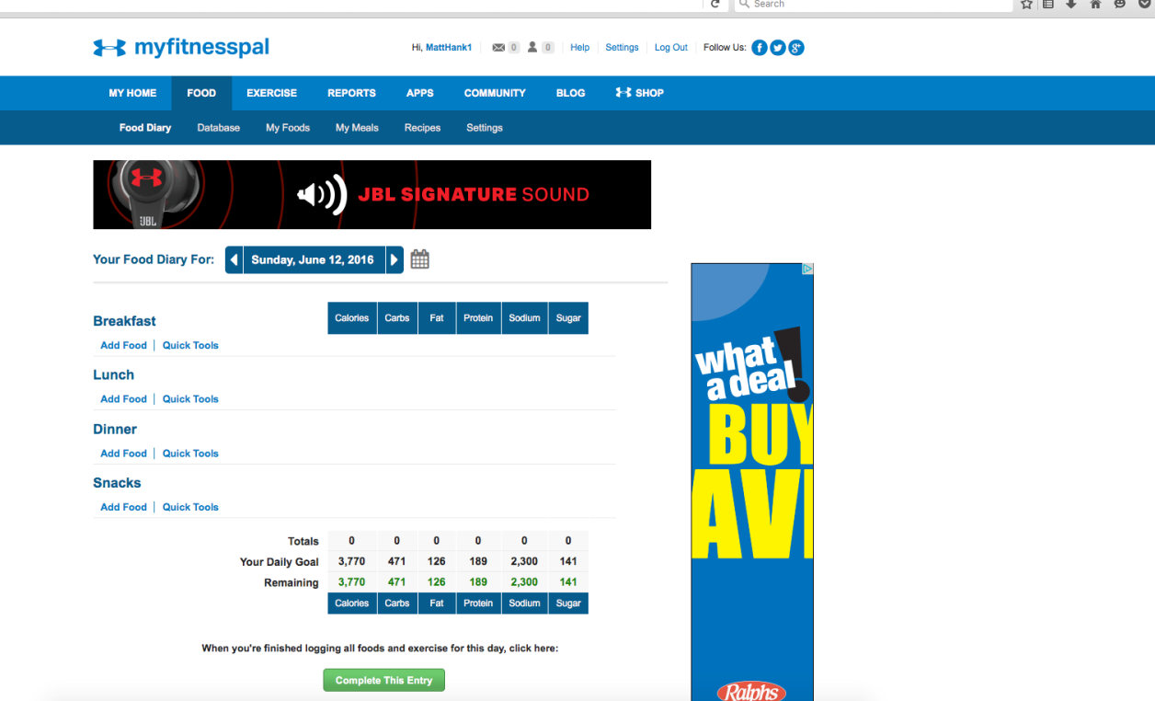
I selected “Add food” under the “Breakfast” category
2 - Entering a specific food item
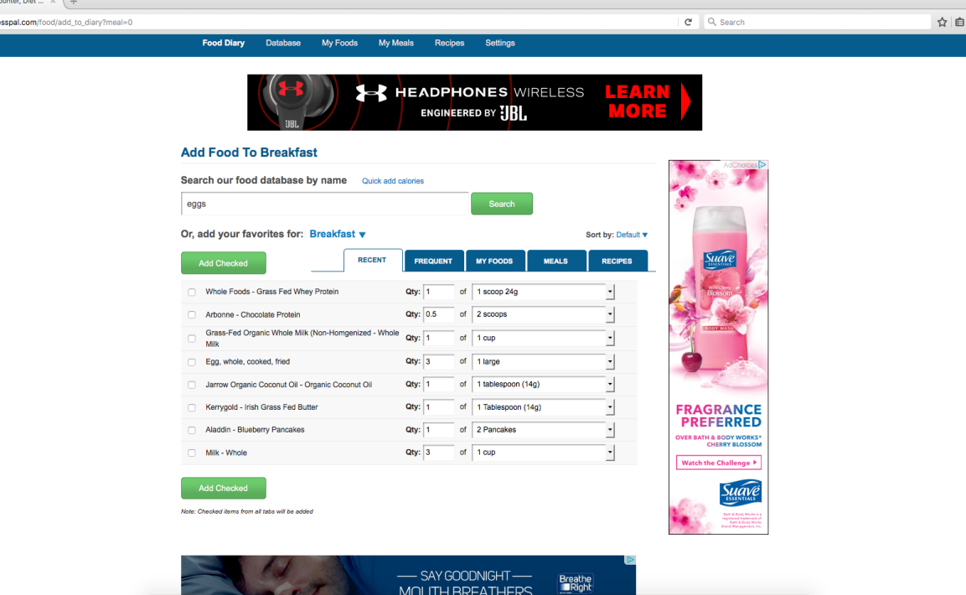
I typed in “eggs”
3 - Selecting the food item
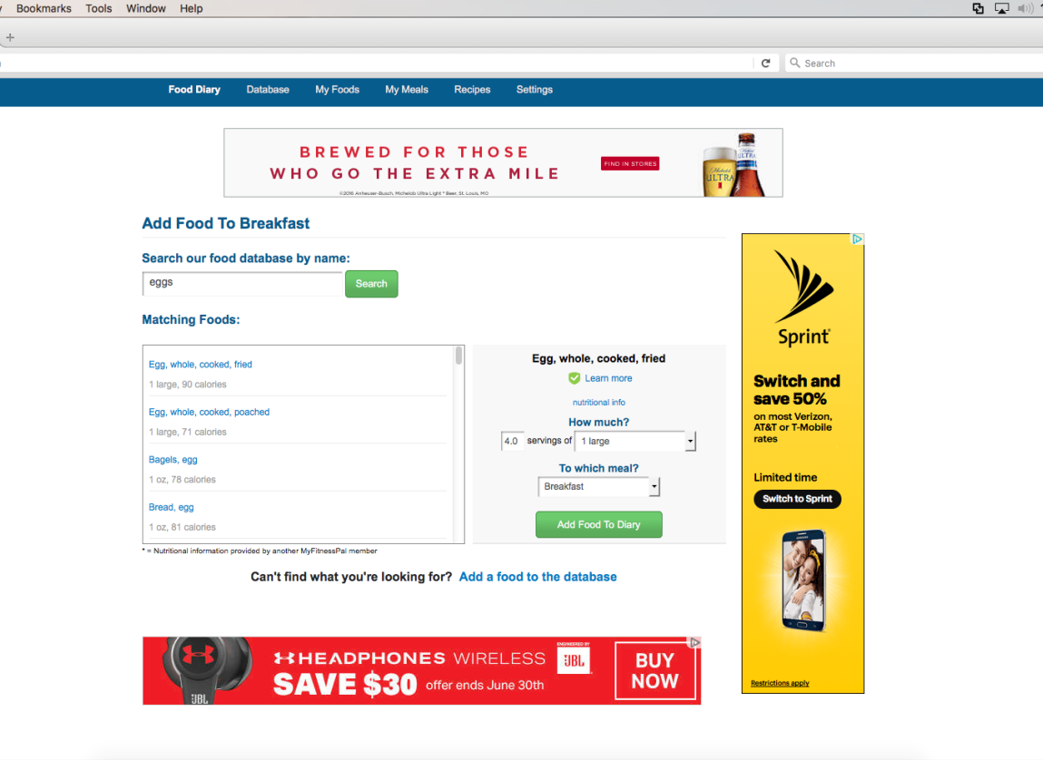
I clicked the first item that came up “egg, whole, cooked, fried”. Then I clicked “add foods to diary”
4 - Viewing the food entry
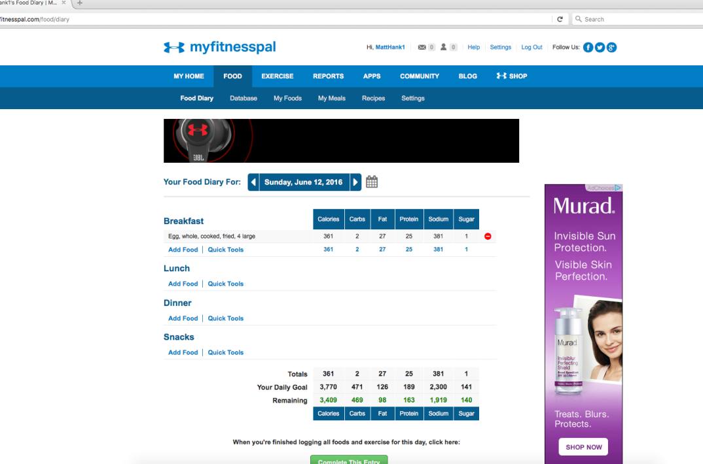

5 - Completed food diary for Day #1
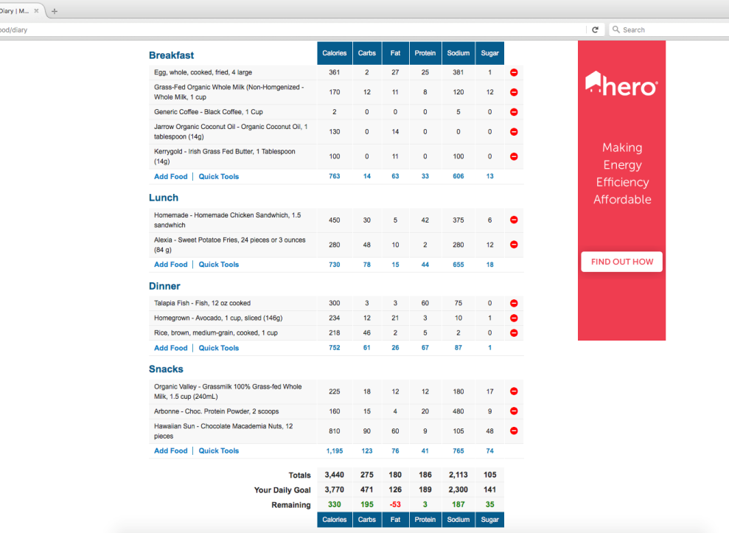
Now you can view the macronutrients for each meal and for the entire day
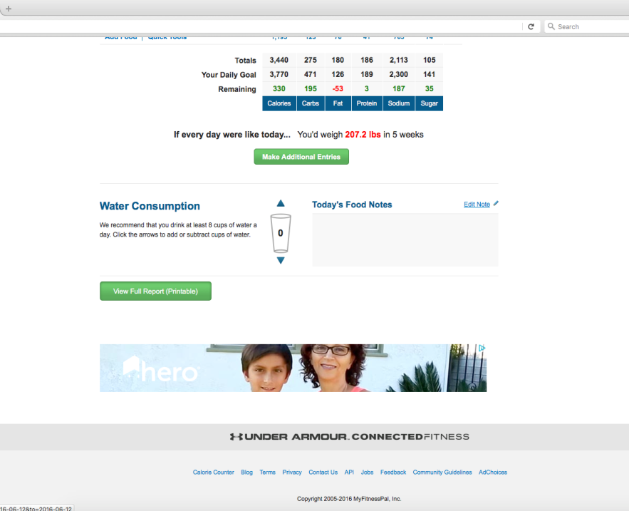
6 - Printable Diary
